*Analyzes Gopuff’s internal and external risks using SWOT analysis, a Risk Register, a Risk Heat Map, and Indicators & Warning Analysis.*

**Assignment**

**6**

A6

ALY6130 Risk Management for Analytics

Assignment 6 – Signature Assessment

**PREPERATION:**

By: John DiSessa

For: Professor Dooley

On: May 22nd, 2022

Introduction

This report analyzes Gopuff’s position within the mobile delivery industry, identifies their internal and external risks, qualitatively and quantitively assesses each risk, and provides effective risk response strategies to ensure Gopuff succeeds in the industry. We used SWOT Analysis, a Risk Register, a Risk Heatmap, and Indicators & Warning analysis to provide Gopuff’s management team a plan to satisfy their main risks.

Background

**What is Gopuff?**

Gopuff is a smartphone delivery app where customers can get “daily essentials delivered in minutes”. Gopuff has set themselves apart from the competition by being the first major player to effectively and affordably deliver snacks, cleaning supplies, health, and other products to customers in about 30 minutes and is available 24 hours per day. They were founded by 2 Drexel students in 2013 and have since expanded into over 1,200 cities worldwide. They employ over 10,000 people and earned almost $2 billion in revenue in 2021. Their success has gathered the attention of competitors like Uber, who have just announced a groceries delivery capability to Uber Eats. They traditionally competed against food delivery companies like Grubhub and DoorDash, but also with Amazon’s Fresh and Prime departments.

**SWOT Analysis**

Our Gopuff SWOT analysis concisely summarizes their internal strengths and weakness as well as their external opportunities and threats. This SWOT analysis provides a comprehensive summary of Gopuff’s position in the industry. The strengths show what they excel at and how they separate themselves from the competition. The weaknesses highlight areas of concern or improvement that they can have direct control over. The opportunities point out areas where they can expand or grow their business. The threats show potential hindrances to their business that could hurt or destroy their success.

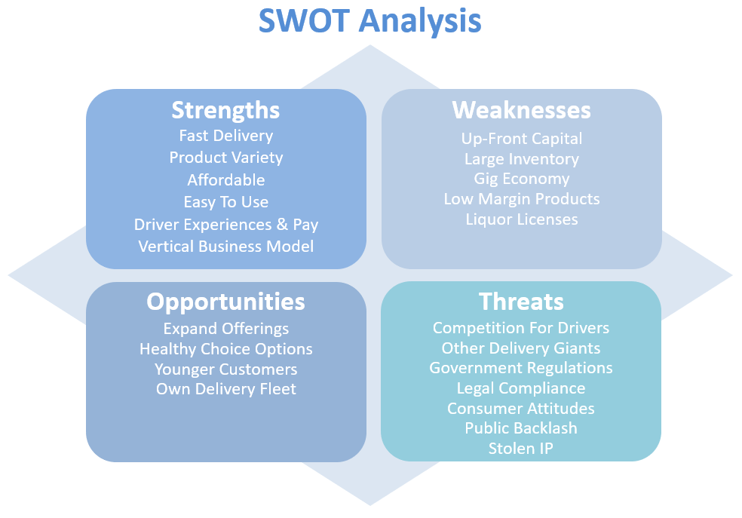

*Strengths*

Gopuff’s app is free to download in all major app stores for all smartphones. It is simple to use since customers simply select all the items they want, add them to their carts, and select delivery location and payment method. Their app offers 12 categories of products including snacks, alcohol, health, cleaning, and pets to name a few. Gopuff only charges a small mark-up on products and a $2.95 delivery fee. Their business model is unique compared to other delivery services since Gopuff owns their own warehouses where they manage their own inventory. Other delivery companies pair drivers with various restaurants, but that is risky since they don’t control product offerings or inventory. This way, Gopuff can have full control over their inventory to provide a consistent customer experience. Other delivery apps face immense competition, such as Grubhub, Uber Eats, Postmates, DoorDash, etc. Many of them have merged, but they all serve the same needs (restaurants). These services can hurt consumers with uncontrollable restaurant markups, varying costs, and unpredictable inventory (restaurant offerings). It is an arms race to partner with as many restaurants as possible, and there is nothing stopping one restaurant from partnering with all of the delivery apps. Gopuff drivers always pick up from the same warehouse. Warehouse workers can prepare orders ahead of time so drivers can pick up and go, ensuring their 30-minute delivery time. Other delivery apps have drivers park at restaurants, walk-in and wait for the customer’s order, then drop it off. Gopuff’s vertical integration allows for more control over the process.

*Weaknesses*

Since they manage their own warehouses, expanding to other cities requires a large capital investment. They have to purchase and stock their warehouses before even taking a single order. Each warehouse always has to be fully stocked. Since they offer a wide variety of products, customer orders are more variable and they need products in stock to complete each order and continue offering a wide variety. It is difficult to raise enough money from margins alone since many of their products are low-margin, like chips, sodas, and paper towels. They rely on high-volume to offset their low margins which can be risky due to outside factors. They also are dependent on hiring enough drivers in this “gig economy” that all of the other delivery apps are competing for. They keep their employment costs low by not having drivers on the payroll, but are solely dependent on the current gig economy staying strong. Lastly, they need to acquire liquor licenses in each city they operate in. This can be expensive and time consuming as well as difficult since each city has their own laws for getting new and renewing liquor licenses.

*Opportunities*

They have started to delivery basic grocery items, but could easily expand their grocery selection by merging with Instacart, for example. Grocery items are more essential and usually offer better margins. Gopuff has the reputation of delivering unhealthy snacks, but with such large inventories, can push into the healthy food space. This could open themselves up to a whole new audience by marketing their healthy choice options and eco-friendly products. They have a potential advantage over other delivery apps that focus on restaurants since their low-margin products and quick delivery are more accessible for younger customers than take-out from restaurants that can be more expensive. They can reach customers before Uber Eats and other competitors can so they can grow their market share if they keep their retention rate high. They also have the potential to own their own delivery fleet. This would further separate them from the competition by offering better pay and more consistent hours for drivers, as well as protecting themselves from the variability of the gig economy.

*Threats*

When looking at Gopuff’s threats, we must first address delivery. Since delivery is essential to their operations, their business could suffer if it becomes more expensive to pay drivers or if there simply are not enough drivers to meet their demand. Competitors with larger revenue and funding streams could incentive drivers to work for them by paying more or offering better benefits. Competitors could also expand their product lines to match Gopuff’s offerings, like we recently saw with Uber Eats. Gopuff also has to consider government regulations hindering their operations. Gopuff offers alcohol, sexual health products, and products that are dangerous if consumed by children. The government could feasibly prohibit them from selling these products citing safety violations or if there are changes to the laws. Gopuff must also have strict age verification checks to avoid delivering alcohol to minors or the government could force Gopuff to cease operations. Since Gopuff does offer these types of products that society generally considers to be vices, consumers could reduce their consumption or make a public backlash against Gopuff making it easy to purchase these products. Gopuff must also protect their unique, easy-to-use app, as well as their proprietary algorithm for accepting orders and assigning drivers. This is one of their most crucial differentiators that could destroy their business if this or something similar ends up in the hands of a competitor.

Risk Identification

We have categorized Gopuff’s main risks into four categories: Strategic, Operational, Compliance/Legal, and Technology. Strategic Risks include offering too many SKUs, their expansion strategy into new cities, and their decision to outsource their drivers. Their Operations Risk is that there are transportation issues during deliveries. Their Compliance/Legal Risks include adhering to changing government regulations, conducting background checks on their drivers, and have working age verification in their app. Their Technology Risk is being dependent on a proprietary algorithm that matches drivers with orders and gives them the optimal delivery routes.

*Strategic Risks*

One of Gopuff’s strengths is that they offer many SKUs (wide variety). However, many products are socially taboo and would be inappropriate if minors got their hands on them. Having so many products also increases their inventory costs and requires large warehouses which tie up valuable capital. Because of this, when they expand into new cities, they need to buy land, build a suitable warehouse, and fully stock that warehouse before even taking a single order. If the customers in that city do not support their business, they would have wasted a ton of resources. Their last strategic risk is their decision to outsource drivers. By not employing drivers full-time, they have drivers work uncommon hours, leave them dependent on tips, and are at risk of losing many drivers to competitors or to changes in the economy.

*Operational Risk*

Since Gopuff markets themselves as a company that can deliver orders in 30 minutes or less, they are subject to risks that are both in their control and also due to external factors. Drivers could get stuck in city traffic, hiring poor drivers could make them more prone to accidents, and even good drivers can get into car accidents that are not their fault. If any of these incidents occur, the customer would not receive their order on time and make them less likely to order from Gopuff again.

*Compliance/Legal Risks*

Because Gopuff outsources their drivers, they must constantly perform background checks on the drivers and therefore, have less information and control than if they were full-time employees of Gopuff. Gopuff must also strictly apply age verification checks on their app to ensure that every customer is of legal drinking age before purchasing alcohol. If they mess up with even one glitch, or apply the wrong code from different cities with different laws, they subject themselves to government lawsuits or potentially cease and desists. They must abide by laws in each city even though it is difficult to keep up with the different laws each city enforces. Governments in some cities may change laws while others don’t and Gopuff must always adhere to any changes.

*Technology Risk*

Their proprietary algorithm, that matches drivers with orders and assigns drivers to the optimal delivery routes, is currently a competitive advantage that allows them delivery in under 30 minutes. However, since it is so valuable, they are open to other companies stealing their software. More likely, competitors could create an algorithm that is better than what Gopuff has and therefore, steal market share.

*Positive Risks*

The following Risk Register shows mostly negative risks that could hurt or destroy the business. However, there are some potentially positive risks. Even though it is expensive to maintain an inventory for so many SKUs, increasing the number of SKUs they have could attract more customers. They could increase their market share by appealing to a wider audience. Since Gopuff outsources their drivers, they are at risk for high turnover and subject to competition for drivers from other companies. However, outsourcing their drivers results in a significantly lower payroll since they don’t have to cover employee benefits. They can use the capital to improve their business elsewhere. Lastly, they are subject to drinking age restrictions in each city and must abide by city changes. It is possible that some cities may actually lower the drinking and thus introduce them to younger customers.

Risk Assessment

**Risk Register**

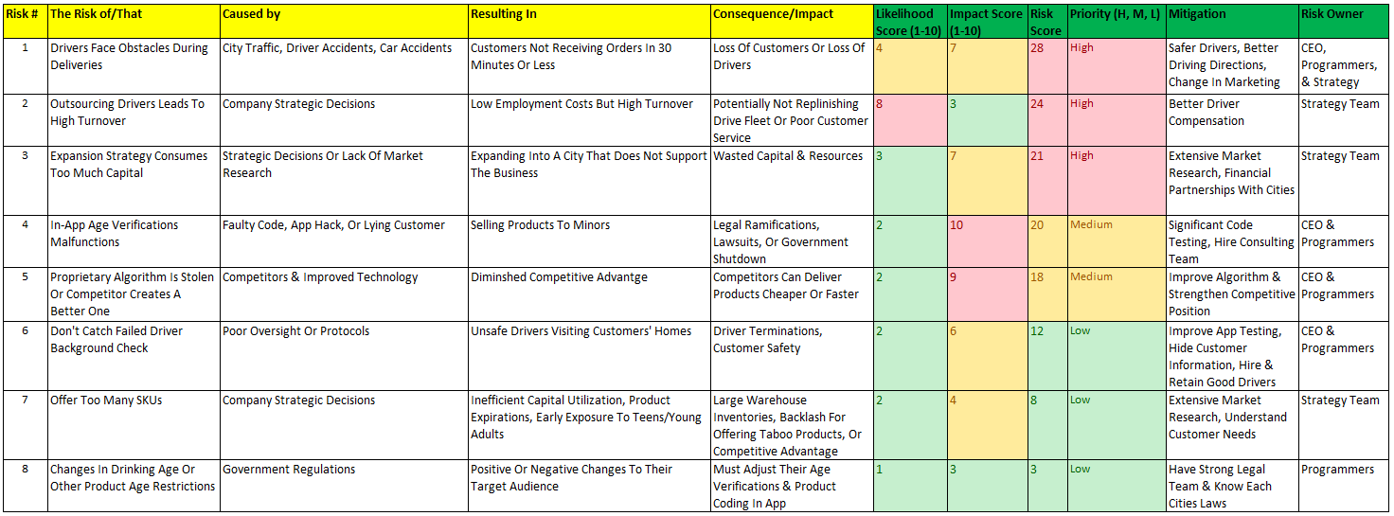

We created risk statements, calculated each risk score, ranked them from high priority to low priority, identified mitigation strategies, and identified the owners for each of the eight identified risks in the Risk Register. All eight were covered in the Risk Identification section, but we will break down the three high priority risks in detail below.

*Risk 1*

*Risk Statement:* The risk that drivers face obstacles during delivery is caused by city traffic, driver accidents, or car accidents, resulting in customers not receiving their orders in 30 minutes or less.

*Risk Assessment:* The consequences of these circumstances happening could be a loss of customers for failing to deliver on their promise or a loss in drivers who are frustrated with traffic or injure themselves or their vehicles during an accident. Because Gopuff operates in 450 cities, they are prone to these incidents occurring occasionally. When they do, customer and driver satisfaction is significantly hurt. The risk is first owned by the CEO since it is their main risk. It is also owned by programmers to ensure their app takes drivers on safe routes and owned by the strategy team for setting customer expectations so high at the risk of driver safety.

*Risk 2*

*Risk Statement:* The risk that outsourcing drivers leads to high turnover is caused by their strategic decisions, resulting in low up-front employment costs but inconsistent staffing due to high turnover.

*Risk Assessment:* As previously mentioned, outsourcing drivers results in them being dependent on a strong gig economy. If economic conditions change, their driver fleet could suffer. This strategy also opens themselves up to directly compete with other delivery giants for the same drivers, since many of them also outsource drivers. Between an economy shift and increasing competition for drivers, Gopuff could permanently hurt their customer satisfaction if they are not able to deliver goods in a timely manner. This risk is primarily owned by the strategy team since they are choose to compete in the market with this strategy. They are willing to risk their driver fleet, or be forced to changed strategies as conditions change, in favor of preserving up-front capital by not hiring their own fleet.

*Risk 3*

*Risk Statement*: The risk that Gopuff’s expansion strategy consumes too much capital is caused by their strategic decisions or lack of market research, resulting in high up-front costs to build and stock a warehouse in a new location without the guarantee of a return on investment.

*Risk Assessment:* Even though Gopuff has succeeded into expanding into new cities, their rapid growth has required an exorbitant amount of funding from many external investors. These investors have demanded a quick return on investment that can only be fulfilled if they generate millions of dollars in revenue from their new cities. Since their business model requires a fully functional operation before being available to customers in the new cities, they have little room for error since they will only be able to repay investors with the money generated from the new cities. This risk is owned by the strategy team since it is their conscious choice to expand rapidly at the risk burning through their capital. They were required to fund this expansion strategy externally which only increased the pressure to succeed.

**Risk Heat Map**

After identifying and scoring Gopuff’s top 8 risks, we created a Risk Heat Map to better quantify Gopuff’s risks as well as plot them in a chart. This allowed us to quickly analyze each risk. The Risk Heat Map provides a simple and intuitive way to identify the severity of each risk and compare each risk to the other risks in order to prioritize them.

In order to create the Risk Heat Map, we used the Risk Register and the risk calculation sheet. These tools gave a great foundation to quantify the likelihood and severity of our risks. The Risk Register allowed us to show clear risk statements and provide a baseline of the risk scores (impact x likelihood). However, adding the risk calculation sheet gave us better insights into accurately quantifying each risk as well as properly categorizing each risk. Rather than providing arbitrary likelihood and impact scores and multiplying them together like in the risk register, the risk calculation sheet gave us consistent scales to use. For the probability of occurrence scale, we took a quantitate approach with the scale ranging from 0% to 100% with each risk percentage as the actual likelihood a risk would happen. For the severity of occurrence, we used a 1-9 (low-high) scale. A severity of 1, 2 or 3 was considered low severity. A severity of 4, 5, or 6 was considered medium severity. A severity of 7, 8, or 9 was considered high severity. The risk calculation sheet also made it easy for us to categorize our risks. We organized our 8 risks in these 4 categories: Strategic, Operational, Legal, and Technology. Using our Risk Register, Risk Calculation Sheet, and other tools from class and independent research, we created the following Risk Heat Map for Gopuff.

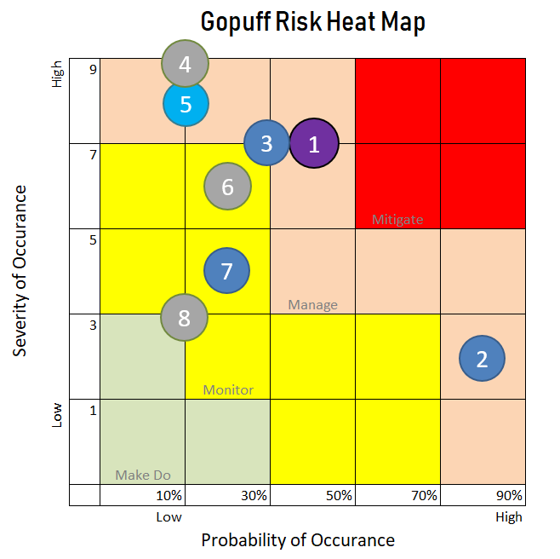

Risk Response Strategy

We divided our Risk Heat Map into the 4 sections: Mitigate, Manage, Monitor, and Make Do. Thankfully, we did not find any risk in the dark red (mitigate) section of our heat map. However, we had 4 risks in the orange (manage) section that will require action from Gopuff to reduce or remove these risks. We had 3 risks in the yellow (monitor) section that wouldn’t necessarily require Gopuff to change their strategic objectives but should be actively monitored. And lastly, we had 1 risk in the green (make do) section that does not currently require any action from Gopuff.

We categorized the following 8 risks into 4 categorized and color-coded them on the Risk Heat Map. Purple = Operational. Dark Blue = Strategic. Light Blue = Technology. Grey = Legal.

1. Drivers Face Obstacles During Delivery
2. Outsourcing Drivers Leads to High Turnover
3. Expansion Strategy Consumes Too Much Capital
4. In-App Age Verification Malfunctions
5. Proprietary Algorithm Is Stolen or Competitor Creates a Better One
6. Don't Catch Failed Driver Background Check
7. Offer Too Many SKUs
8. Changes In Drinking Age or Other Product Age Restrictions

*Mitigate*

No risks entered this section. However, Risk 1 was the closest and thus should be the first priority.

*Manage*

Risks 1, 2, 4, and 5 all definitively fall into this section and should be addressed before the other risks. To manage Risk 1, Gopuff needs to ensure their delivery app efficiently guides drivers away from traffic and they need to set expectations with consumers about delivery times when ordering during busy hours. Gopuff could also conduct driver safety and training courses. This would help manage Risk 2 since they consistently hire new drivers with varying levels of driver safety skills. To manage Risk 4, Gopuff should increase their app testing, hire additional software engineers, and make the age verification process easier to reduce customer confusion. For Risk 5, Gopuff needs to invest time, money, and strategic directive in order to consistently improve their algorithm at a faster rate than competitors can improve theirs. They also need to conduct significant market research on competitors to track their progress.

*Monitor*

Risks 3, 6, and 7 do not currently require any action but Gopuff must at least monitor them. If the first four risks were addressed, these three should be addresses after the others were properly managed. Risk 3 does not necessarily require a change in their expansion strategy, but they need to sufficiently study each new market they enter to be extremely confident that they could be financially supported. Risk 6 simply requires Gopuff to keep ensuring driver information is accurate and they need to check that the background verification company they hire still complies to government standards. Risk 7 does not require Gopuff to change their product offerings. In fact, their wide variety of SKUs is attractive to customers. However, they need to conduct market research to be sure that they product offerings are still desired by consumers so they can still be profitable.

*Make Do*

Risk 8 is entirely out of Gopuff’s control. However, there is the potential for the legal ages to decrease which would only benefit Gopuff. Gopuff should be aware of any possible legislation affecting these changes. But, in the meantime, can operate without worry of this risk.

The Risk Heat Map allowed us to better quantify Gopuff’s risks compared to analyses in previous assignments. We used our Gopuff Risk Register as well as our newly created risk calculation sheet to create the heat map that is simple, intuitive, and accurate. The risk calculation sheet gave us more accurate likelihood and impact scales and allowed us to better categorize our risks. The Risk Heat Map easily allows us to prioritize risks, compare them to other risks, and easily identify the severity and likelihood of each risk in order to best advise Gopuff. Gopuff needs to address risks 1, 2, 4, and 5 by making some changes to their business processes. Gopuff does not necessarily need to make changes to reduce risks 3, 6, and 7 but at the very least, needs to monitor them and have plans in place in case market conditions change. Risk 8 does not currently require action, however consistently monitoring this would prevent lawsuits or potentially widen their customer base.

Key Risk Indicators

Previously, we qualitatively and quantitatively assessed Gopuff’s risks. However, we took an additional step studied Gopuff’s hypothetical risks due to competitor activity. We looked at potential competitor actions using Indicators & Warning analysis to identify how competitors would be able to diminish Gopuff’s profitability.

**I&W Strengths & Weaknesses**

Gopuff can use our I&W analysis to implement a proactive approach towards competitor-centric risk assessment. Gopuff would be able to understand current and potential changes that occur in the competitive landscape. We provided 5 hypothetical indicators that Gopuff can consistently analyze in order to understand the changes competitors are making and how Gopuff can shape their decision making to mitigate those changes. Gopuff would be able to modify and set strategic priorities with a data-driven approach. However, I&W analysis can be harmful if not implemented properly. Since this analysis requires constant monitoring and data tracking, Gopuff needs to ensure they dedicate resources to the cause. They need to have an intelligent staff that can properly identify indicators and convey potential changes to management. There could be datapoints that indicate a competitor’s actions, or there could be false datapoints that lead Gopuff astray. Sifting through the noise and identifying the signals accurately is imperative to Gopuff’s success.

**Gopuff I&W Analysis**

We developed 5 indicators for Gopuff to monitor going forward using the I&W analysis. Each indicator includes a meaning, significance level, warning sign, and our recommendations. It’s also important to establish meaning behind each indicator so for each one, we analyzed the motivation, opportunity, capabilities, method, and imminence.

Motivations: What are the competitors are hoping to achieve?

Opportunities: How would the indicators affect their bottom-lines?

Capabilities: What resources do they have?

Methods: Are the indicators strategic, tactical, or operational?

Imminence: How soon would they take effect?

*Indicator 1 – Competitive Mergers & Acquisitions*

Competitive Mergers & Acquisitions are extremely concerning for Gopuff because it means that competitors are aligning their synergies, helping each other’s weaknesses, and become larger companies with more resources and broader customer reach. Gopuff needs to constantly monitor competitors’ financial documents and any Wall Street Journal reports that could indicate a merger or acquisition. For example, Uber Eats purchased Postmates for $2.65 billion worth of stock. A move of this caliber could not have happened overnight so Gopuff had ample time to become aware of this acquisition. In these situations, Gopuff needs to act quickly and decide whether to attack them or avoid them. They could choose to avoid by allowing them to focus on dinner deliveries while Gopuff focuses on their own type of deliveries, however this acquisition could indicate a larger corporate strategy by Uber Eats. Gopuff needs to identify their strategy and invest more of their resources into that side of their own business.

*Indicator 2 – Increased Driver Compensation*

This is another extremely significant indicator for Gopuff since their driver fleet is essential to their delivery business. If competitors increase driver compensation, they would be looking to increase the size of their fleets or increase driver retention. Both scenarios hurt Gopuff’s abilities to recruit drivers if they work for other companies. Even though there are many different ways compensation can be awarded, we would look at if the average hourly wages of competitors’ drivers exceed 10% of Gopuff’s hourly wages. If there is more than a 10% difference, we believe that is too much for Gopuff to overcome without other incentives. We recommend increasing driver pay, offering better hours, giving drivers more flexibility, or offering various compensation tiers to reward their recurring drivers.

*Indicator 3 – Ads to Recruit Drivers*

Similar to Indicator 2, this indicator shows a clear desire to increase their driver fleets. The larger the competitors’ driver fleets get, the harder it becomes for Gopuff to poach their drivers since they are all competing to employ the same drivers. This indicator could mean that competitors are falling behind Gopuff in driver recruitment. More likely however, it could indicate a weak gig economy which affects the entire industry. If competitors exceed $1 million in ad spending during a 6-month window, that should cause Gopuff to take notice. If this happens, Gopuff needs to re-assess the driver market and double down on driver recruitment. This is an opportunity to suffocate competitors since they are desperate for drivers.

*Indicator 4 – Investments in Startups*

Startups are typically known for their potential to make significant improvements to their industries. If a competitor invests significantly in a startup, it is possible they are looking to acquire superior technology that could give them a competitive advantage. This threat is low since the failure rate of startups is very high, but if a competitor invests more than $5 million in new companies, that indicates their high conviction in the benefits the startups bring to the industry. Gopuff must identify the technology, business propositions, etc. that makes the startups valuable. Once Gopuff has a clear picture of what the startups can do to help the competition, they must outbid the competition, buy superior technology, or develop it themselves.

*Indicator 5 – Government Intervention*

Even though this is the lowest significant indicator, it still has the potential to ruin Gopuff’s operations. If the government forces operational changes for a competitor, there is a strong chance the government will force those same changes across the entire industry. For example, if the government banned Drizzly from delivering alcohol, it is likely that soon the government will ban Gopuff from delivering alcohol. Gopuff needs to work with lawmakers and government officials to be up-to-date on potential law changes or enforcements. They also need to prove to each local government that their business is an asset to the city’s economy and that they are a values business to the city residents.



Our I&W analysis gives Gopuff a clear outline for analyzing their competitors actions that could pose a threat to Gopuff’s profitability. We provided Gopuff with 5 indicators that show the risk to Gopuff, how significant the risks are, what the quantitative warning signs are, and how Gopuff should address the risks. If not done properly, I&W analysis could make it difficult to differentiate between the noise and the signals. However, we outlined clear indicators, warning signs, and action items for Gopuff’s intelligent management team to adjust their strategy and mitigate competitive risks.

Conclusion

Our analysis included a complete picture of Gopuff’s internal, external, and competitive risks. We identified risks from various categories as well as the risks stemming from Gopuff’s own strategic decisions and known tradeoffs. Those risks were analyzed, benchmarked, and given thoughtful risk response strategies. We used a SWOT analysis to concisely show Gopuff’s place in the industry, a Risk Register to summarize the top 8 risks to Gopuff, a Heat Map to quantify those risks, identify priorities, and how to address each risk, and an Indicators & Warnings Analysis to give Gopuff 5 indicators they need to use to be aware of competitive changes. We are confident that this report will be satisfactory to Gopuff’s leaders. Gopuff is extremely well positioned to be an industry leader for years to come.

Citations

“Catch Gopuff If You Can – A Vertically Integrated Consumer Tech Company Delivering Instant Needs.” *Yahoo!*, Yahoo!, https://www.yahoo.com/video/catch-gopuff-vertically-integrated-consumer-151641879.html.

Debter, Lauren. “Beer, Band-AIDS and Ben & Jerry's: Why Venture Capitalists Gave Two 27-Year-Olds $1 Billion to Build the Ultimate Online Convenience Store.” *Forbes*, Forbes Magazine, 29 Jan. 2021, https://www.forbes.com/sites/laurendebter/2020/08/31/gopuff-1-billion-venture-capital-online-convenience-store/?sh=56a688fe28f0.

*Gopuff*, https://gopuff.com/#categories.

Hayes, Adam. “How Enterprise Risk Management (ERM) Works.” *Investopedia*, Investopedia, 9 June 2021, https://www.investopedia.com/terms/e/enterprise-risk-management.asp.

“How Instacart Brings Comprehensive Business and Revenue.” *JungleWorks*, 14 Apr. 2022, https://jungleworks.com/how-instacart-works-makes-money-revenue-business-model/.

Asana. “11 Templates to Help You Plan and Manage Your next Project • Asana.” *Asana*, https://asana.com/resources/project-plan-templates.

Asana. “What Is a Risk Register: A Project Manager's Guide with Examples • Asana.” *Asana*, https://asana.com/resources/risk-register.

Author, About the. “Menin Calls on Gopuff Delivery Service to Halt Its Hazardous Business Practices in Upper East Side.” *AmNewYork*, 24 Feb. 2022, https://www.amny.com/news/menin-calls-on-gopuff-delivery-service-to-halt-its-hazardous-business-practices-in-upper-east-side/.

*How Risk Assessment Scores Are Calculated*, https://www.ibm.com/docs/en/elm/6.0.6?topic=risk-how-assessment-scores-are-calculated.

Caldas, Antonio. “How to Create a Risk Heatmap in Excel - Part 2.” *Risk Management Guru*, 4 Sept. 2018, https://riskmanagementguru.com/create-risk-heatmap-excel-part-2.html/#:~:text=%20How%20to%20Create%20a%20Risk%20Heatmap%20in,is%20to%20file%20in%20your%20risk...%20More%20.

“Eight Steps to Creating a Risk Heat Map.” *Eight Steps to Creating a Risk Heat Map | Instituut Van Internal Auditors*, https://www.iia.nl/actualiteit/nieuws/eight-steps-to-ceating-a-risk-heat-map.

Ladd, Brittain. “How Rite Aid and Gopuff Can Disrupt the Convenience Store Industry.” *Forbes*, Forbes Magazine, 20 Aug. 2018, https://www.forbes.com/sites/brittainladd/2018/08/20/how-rite-aid-and-gopuff-can-disrupt-the-convenience-store-industry/?sh=2383151bc3af.

“Tin Whisker Spreadsheet.” *Tin Whisker Risk Spreadsheet*, https://web.calce.umd.edu/tin-whiskers/spreadsheet/.

Fleisher, C. S., & Bensoussan, B. E. (2015). 16. Indications and Warning Analysis. In *Business and competitive analysis: Effective application of new and classic methods*. essay, Pearson Education.

*Bloomberg.com*, Bloomberg, https://www.bloomberg.com/news/articles/2022-03-31/gopuff-is-close-to-raising-1-billion-with-no-ipo-in-sight#:~:text=Gopuff%2C%20whose%20official%20name%20is,grew%2070%25%20compared%20with%202020.

Kenton, Will. “How Swot (Strength, Weakness, Opportunity, and Threat) Analysis Works.” *Investopedia*, Investopedia, 15 Apr. 2022, https://www.investopedia.com/terms/s/swot.asp.

Team, Bestreferraldriver. “4 Things to Know about Uber Eats Grocery Delivery.” *Bestreferraldriver.com*, Bestreferraldriver, 30 Jan. 2022, https://bestreferraldriver.com/uber-eats-groceries.html.